ASSIGNMENT 1: DeVops

1Ans

1. Tried a couple of times to login as a guest user but was unable to do that as to login we need to login as an existing user so while the installation process its very much important to set a username pwd that’s matching the criteria as well as something that’s not easily forgettable.

2ANS

1. Tried to change pass to IneuROn#42

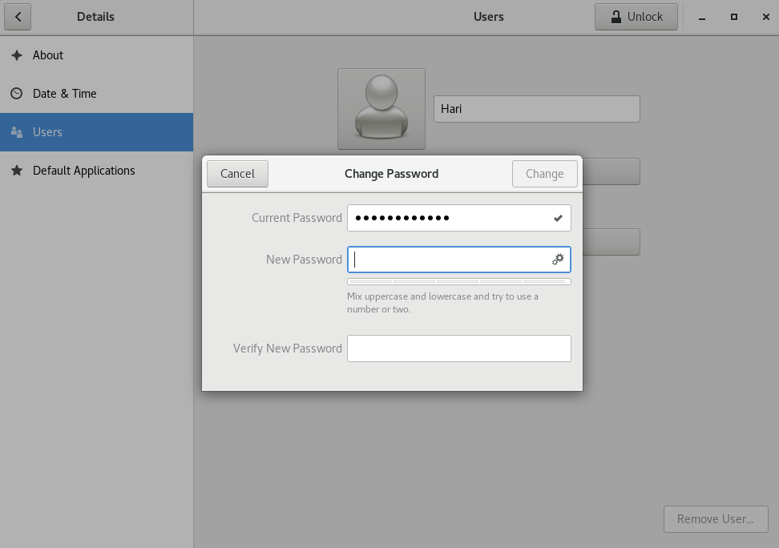

2. After changing the pass I tried to reboot the cent os and tried my old pass it threw an error as expected! so gave the new pass and logged in sucessfully

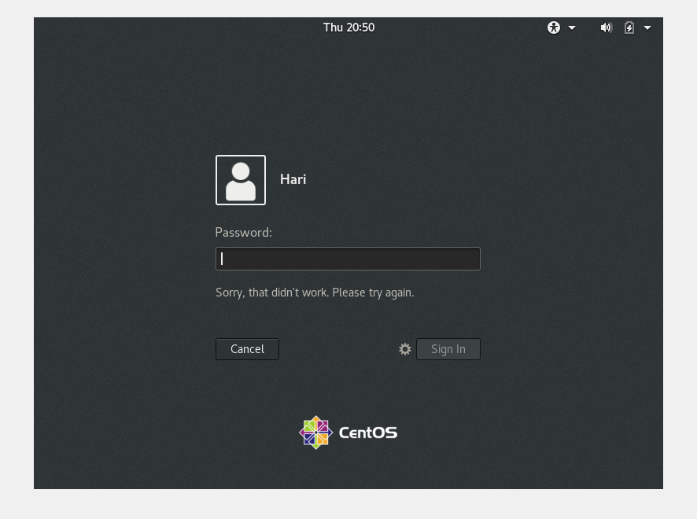

3. now as mentioned in the assignment im trying to change the pass to a really simple one like 12345678

Result: I was unable to change it to a really simple one the change option was not getting enabled

Kudos for the security terms!

The thing I really observed is that we cant use passwords that are of a really simple sequence.

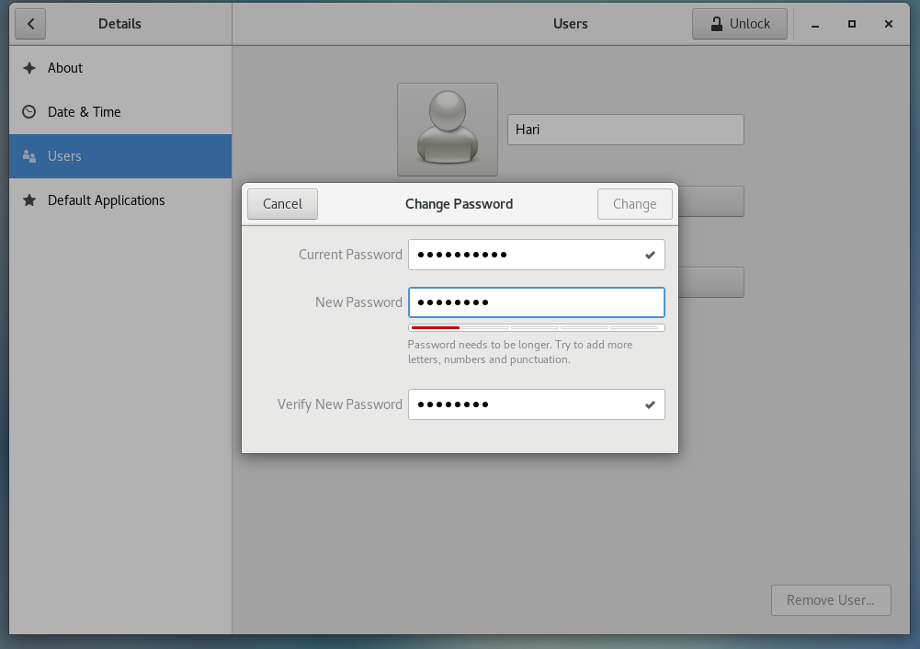

3. now I tried giving no pass and the below is the result I got

Result: it is not allowing or enabling the change button for me to change the password without actually entering one so It’s clear that it’s a must to have a strong password according to the predefined terms in order to login and use the cent os.

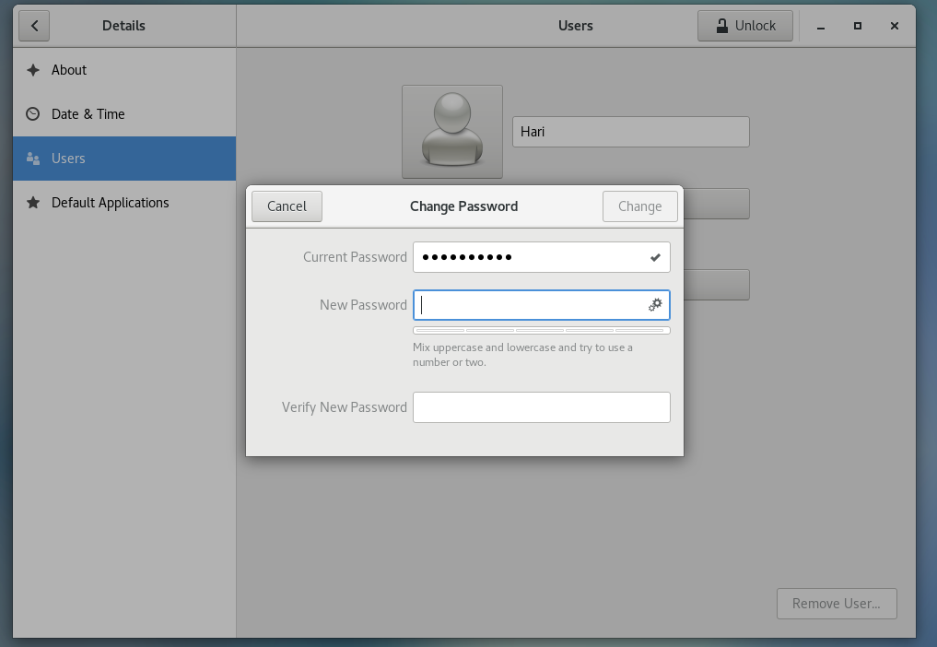

4. finally I have set a password according to the password terms and the change button is enabled as below and I tried to lock and un lock the CentOs and was able to proceed successfully.

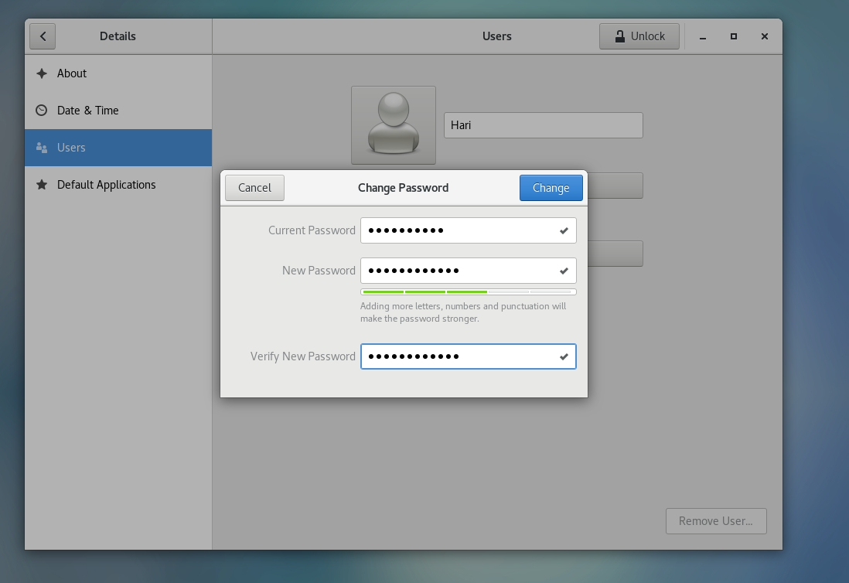

3Ans

* Enter the command **cd /** and then **ls** and then hit **Enter** key

1. when I use the above command the below is the output I got

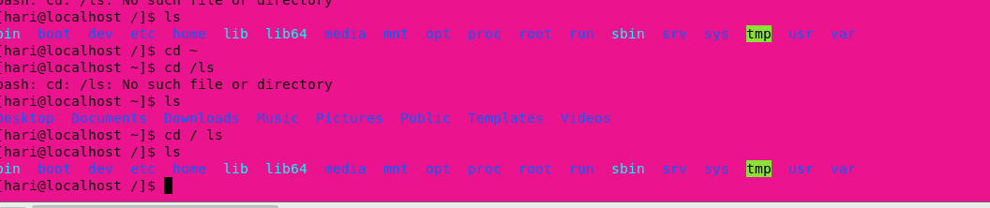

1. So, from above initially when we open the terminal and use ls we have the above directories like bin boot etc so when I toogle to the home page and use the mentioned command I will toggle back or roll back to the previous folders from the below screenshot I got an understanding that no matter which directory we are in we shall roll back to the initial phase

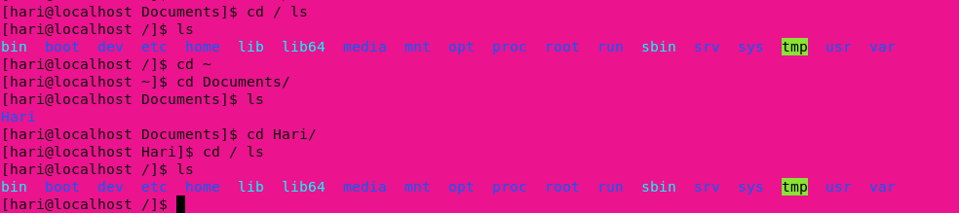

* Enter the command now **cd /home** and then hit **Enter** key
  1. It returns user info maybe

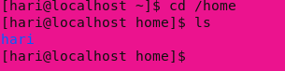

* 1. After running couple of commands, I got to know that once we enter into the Hari, i.e. we will get to home I mean this goes to the parent

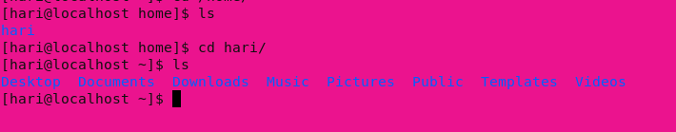

* Enter **cd ..** and hit **Enter** key [ *Note: here we have space after cd then use double dot*]
  1. After using the cmd cd .. I got an understanding that it just goes a step back i.e. it points back to the previous working directory

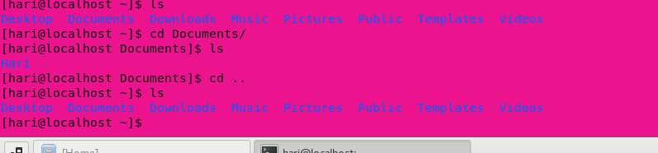

* Now enter **cd /var/www/html** and then type **cd** and hit **Enter** key

1. There is no such directory that exists as defined in the above path

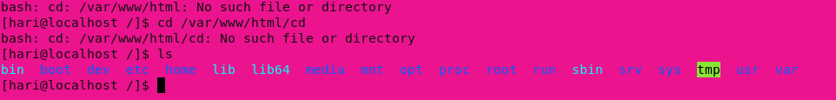

Suddenly I observed that the www/html part is acting like a link though its not redirecting anywhere

* Now type **cd /root** and then hit **Enter** key
  1. After using the above command I got an understanding that we cant directly go or access the root directory we have some special cmds like su or sudo su

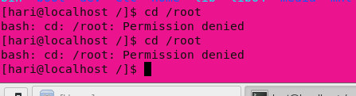

After using the ls cmd there’s no change I’m still in the same directory that I was before using the cmd cd /root

4 ANS:

* Go to **cd /etc** and type **ls**

1. The above command toggles to the etc directory after using the ls command we get to see all the configuration file that are present in the cent os

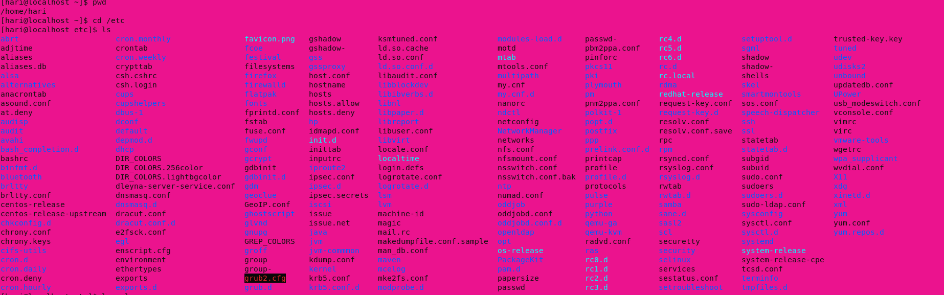

* Then type **ls -al** and hit **Enter** key

1.after using the above cmd got to know all the permissions of the displayed files

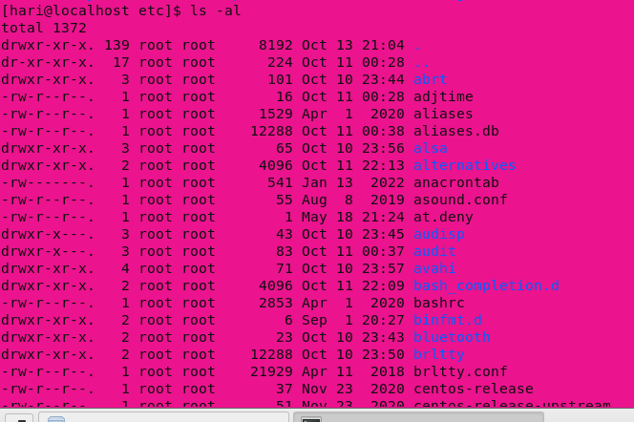

* Then use **ls -i** and hit **Enter** key
  1. The command ls -I is used for displaying the index number of the listed files as below   
     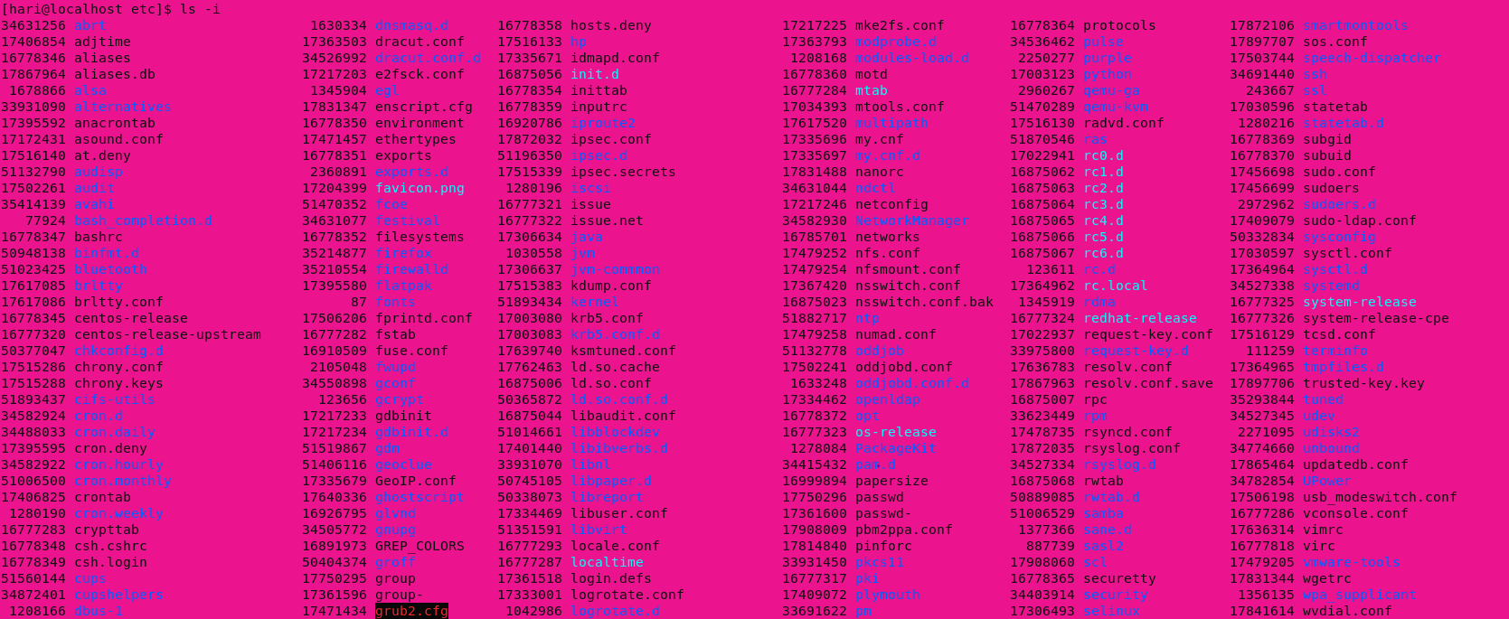

5 Ans:

* Check which location you working, type **pwd** and take screenshot
  1. Pwd after freshly opening a terminal gave me the home and user name as the excat location where im pointed to

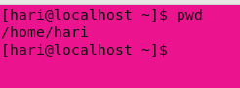

* Now use **cd /var** and hit **Enter** key
  1. Var folder consists of all the variable file to which all the operations performed by the os while its operations are logged into



Live Assignments:

Updated the os also installed all the required dependencies to make the os full screen

Also created a folder I neuron and created a text file inside it and now changed its permissions and tested a couple of times.

